MUUGLines
The Manitoba UNIX User Group Newsletter
Volume 25 No. 5, January 2013 Editor: Trevor Cordes
Next Meeting: January 8th, 2013

RTFM and presentation:
The Raspberry Pi is a fully functional motherboard that fits in the palm of your hand. It has a cpu (ARM11), ethernet capability, 512MB ram, USB 2.0 ports and can run Xwindows. Storage is on an SD card.
This presentation will be in two parts: the first will be a general introduction including installing Linux on the Raspberry Pi. The second will demonstrate the GPIO (general purpose input/output) pins included on the motherboard.
The RTFM features Gilbert discussing lsof and ftop.
Where to Find the Meeting
3D03 Duckworth Centre, University of Winnipeg
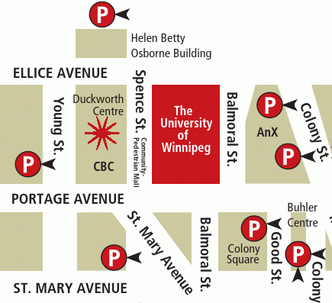

Important: MUUG Has Moved
Our new home is at the University of Winnipeg in Duckworth Centre, room 3D03; indicated on the map above by a big star. Duckworth Centre is at the far northwest of the campus. Parking is available on the surrounding streets and in the lots indicated above by the letter P. Look for signage once you’re at the building, or ask a security guard. If you get lost, text Brad at 955-5691 for help.
Upcoming Meeting

February 12th, 2013
Topic: TBD
Location: 3D03 Duckworth Centre, U of W
Fedora 18 Released

Just in time for our January 8th meeting, a new Fedora shows up: Spherical Cow. New features include 256 color terminal support, easy active directory domain joining, Clojure, FedFS, NFSometer to measure NFS performance, and Secure Boot.
Updates include Boost 1.50, GNOME 3.6, KDE 4.9, PCRE 8.30, Perl 5.16, Rails 3.2, Samba 4, Xfce 4.10, and an improved anaconda installer. Changes include making firewalld the default firewall. For the GnomeShell-averse we now get the option of MATE Desktop, based on GNOME 2.
The name comes from a physics joke:
Milk production at a dairy farm was low, so the farmer wrote to the local university, asking for help from academia. A multidisciplinary team of professors was assembled, headed by a theoretical physicist, and two weeks of intensive on-site investigation took place. The scholars then returned to the university, notebooks crammed with data, where the task of writing the report was left to the team leader. Shortly thereafter the physicist returned to the farm, saying to the farmer “I have the solution, but it only works in the case of spherical cows in a vacuum.”
Benevolent Dictator Miffed
Linus Torvalds recently got a tad upset on the Linux Kernel Mailing List because of some bug-causing commits. Linus proves once again that he doesn’t pull any punches.

https://lkml.org/lkml/2012/12/23/75
Warning: link contains harsh language.
MUUG Meal Mollifies Mavens
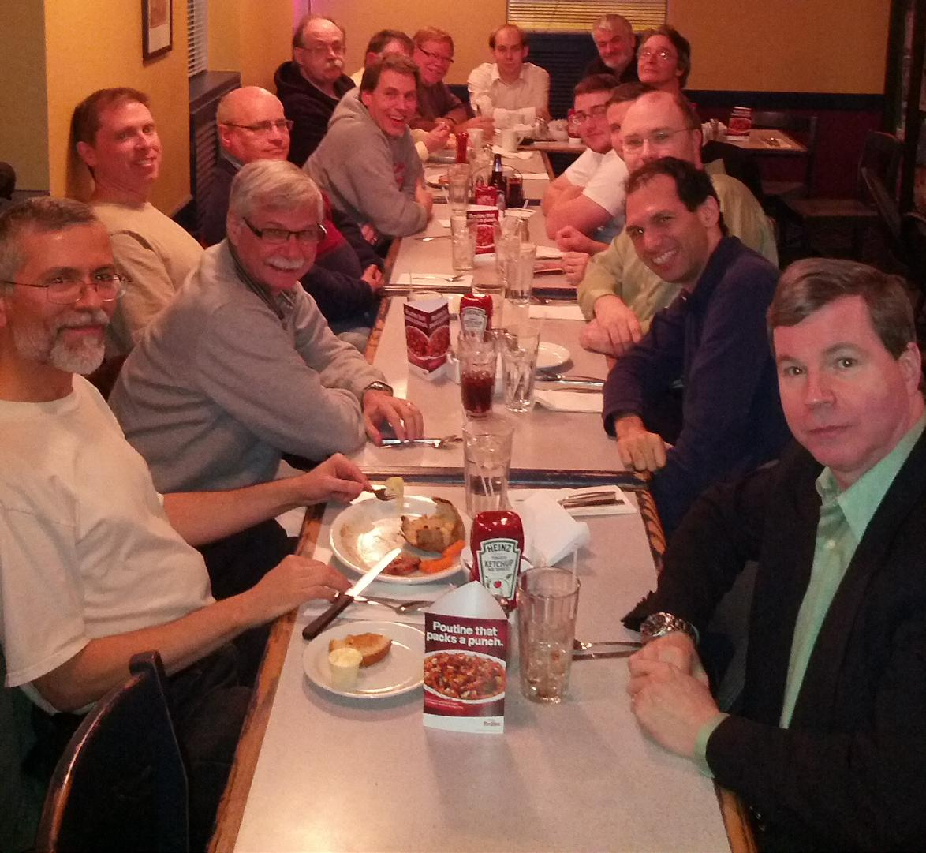
Our special-format December meeting was a success. Thanks to the Seine River Cafe for the excellent culinary fare and superb service. The Apple Crumble Incident is worthy of the MUUG annals.
BSD Updated
FreeBSD released version 9.1 with zfs, VM and network speed improvements. NetBSD released a minor update: 6.0.1.
Hashes Rehashed
A new hash algorithm, BLAKE2, claims to be much faster than SHA-* and faster than even the tried and true MD5 on 64-bit CPUs. At the same time it should offer comparable security. BLAKE2 is a modified, better version of SHA-3 finalist BLAKE. Information and reference code available via this link:

https://blake2.net/
Enlightenment Releases E17
The Enlightenment crew have released the latest version, E17, of this alternative window manager (WM) and toolkit. Those not-so-few unhappy users of GnomeShell and Unity are encouraged to check out the excellent alternatives such as E17, Sawfish and XFCE; all of which are in active development.
FSF Fights Restricted Boot
Further developments in the SecureBoot saga: the FSF is collecting signatures and now donations to stop RestrictedBoot before it becomes pervasive. RestrictedBoot is the tighter form of SecureBoot whereby end users cannot, even via BIOS settings, boot an alternative OS on a device designed for Windows. Microsoft is mandating RestrictedBoot on ARM-based Windows 8 devices, such as phones and tablets, as well as Microsoft’s own Surface tablet.
FSF is asking people to donate $50 minimum towards a $350,000 goal by January 31st.

http://tinyurl.com/czpq2np
JavaScript Linux In A Browser
Too cool! Someone has created a JavaScript version of a PC emulator and it runs Linux. Poke around the Linux command line without installing or rebooting.

http://bellard.org/jslinux/
Another site has taken this and turned it into an educational tool to introduce *nix basics. Visit the site, click on the black box and follow the tutorial below.

http://nixsrv.com/llthw
Btrfs Has DoS Problems
Local users can exploit a hash-collision problem in Btrfs to cause it to slow to a crawl. Sample Python code is available. Maintainers say this should be fixed by kernel version 3.8.

http://tinyurl.com/br6sv9j
Compatibility Chaos
Hardware isn’t always compatible, even when it should be. This reporter has had curious hardware experiences recently, and hopes to save others from similar wasted evenings.
One would think that a SATA drive should work in any SATA system. Sure, there are currently three different SATA link speeds (1.5, 3 and 6 Gbps) but both the drives and the controllers are supposed to negotiate down to the lowest common denominator. And they seem to. However, I have run into problems with brand new Intel SSD’s on older ICH5 (Intel 865 chipset-era) systems. The drive will work fine for a while and then fail. The same drive works fine with a modern board. The clincher is that brand new modern spinning-rust drives work fine in this setup, so it’s just an SSD (or Intel SSD) thing. So much for assured compatibility and upgradability!
In another case, I’ve seen many issues with newer PCI-express cards used with older motherboards. Older in this case being early PCI-express boards circa 2006. As with SATA drives, the cards are supposed to detect PCIe generation (1, 2 or 3) and lane width and adjust accordingly. In practice it seems a crapshoot. Older radeon (X300-era) cards in particular seem to dislike newer boards.
Sure, it’s hard for vendors to test their devices with every other possible device in combination, but this is why we have standards. What this means is that standards aren’t being adhered to all that strictly. It seems to get worse every year. Caveat emptor to all upgraders out there, and make sure you get a good return policy from your retailer.
OSS Gets Speech Recognition
Simon 0.4.0 speech recognition provides decent capability for us FOSS users who have eyed Dragon on Windows with envy. Features include high-quality English speech models and KDE integration.

http://simon-listens.blogspot.ca/2012/12/simon-040.html
Grimrock Game Gratifies
Humble Bundle, which sells Linux (and other) games on a pay-what-you-want basis, released Humble Bundle 7 containing Legend Of Grimrock. It’s a flashy, slow-paced, real-time RPG. Check the screenshots:

http://tinyurl.com/adfhgxs

http://www.humblebundle.com/
GNU Contributor Quits
Paolo Bonzini, maintainer of GNU grep and sed has resigned after a multi-year tenure. Behind the scenes, guys like Paolo handle the unsung jobs of updating the nuts & bolts software we all use daily. He cites obsolete and stale coding standards and language requirements (C) as reasons for quitting. Also indicated is a lack of vision by GNU in general: “Being part of GNU is not an emblem of technical leadership anymore”.
Linux 3.8 Features Fleshed
Linus reports on the pre-release of 3.8 kernel. New is the Flash-Friendly File System (F2FS) for use on USB flash drives and the like, providing improved longevity for those devices. “Balancenuma” features attempt to keep processes and the memory they are using in close proximity on NUMA architectures, which may become more prevalent in the near future.
Also, Ext4 now can store very small files in tandem with the inode entry, saving storage space and potentially increasing speed. NVIDIA Tegra graphics cores also get a simple in-kernel driver.
1k FOSS Summaries
Datamation has published a guide to summarize and recommend over 1000 open source software tools. The list is categorized and alphabetized and presented on their web page. It makes a great reference to check when you want to delve into an unfamiliar area and aren’t sure which of the twenty gazillion projects you should focus on.

http://tinyurl.com/bp3226z
Two Spaces Isn’t Wrong
There is a war going on. It’s nasty. It’s vicious. It’s never-ending. When typing, do you put one space after a “full stop”or two? The majority seem to think two-spaces is the devil. But the two-space camp is fighting back.
An excellent web article proffers some points such as:
- Pre-typewriter standards had much wider spaces after sentences.
- The extra whitespace is not “ugly”, it was said to make sentences easier to parse.
- The move to one space “was driven by publishers who wanted cheaper publications, decreasing expertise in the typesetting profession”.
Personally, I spend most of my day in monospace, in the terminal, in ASCII, and I can’t stand looking at prose with only single spaces. What’s your opinion on the war? Post to the roundtable mailing list!

http://www.heracliteanriver.com/?p=324
Book Review: Version Control With Git by Jon Loeliger
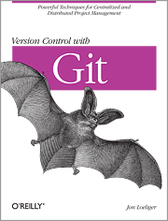
by Trevor Cordes
I found myself requiring a version control system to take a fairly large programming project beyond a single programmer and do away with manual processes for maintaining dev, demo and live versions. Many members of MUUG chimed in and the consensus seemed to be: Git.
As many of us would do, I dove right in, attempting to get Git going and Git-izing my project. I quickly realized, even with the help of online tutorials and copious documentation, that it wasn’t going to be that easy. I needed help. I needed an O’Reilly book.
Many of us have some experience, however cursory, with other versioning systems like RCS, CVS and subversion. Forget them. Forget their paradigm. Their mindset and Git’s are completely incompatible. It’s like the difference between procedural and object-oriented programming. Knowing one hinders your learning the other. Some Git oddity examples include the fact that Git stores entire copies of each commit, not diffs like most systems. Even odder, Git doesn’t have any concept of a central repository, or a “master copy”. It’s easy to say, but hard to grasp the implications.
Version Control With Git (hereafter referred to as VCWG) does not offer a quick fix. You won’t be able to Git-ize your project until you have read most of the book. This is no fault of VCWG: it’s due to the revolutionary nature of Git. VCWG provides the theory and paradigm overview that will help you “get” Git. And “getting Git” is imperative to success. At this the book excels.
Copious examples are included to illustrate how Git commits work, in terms of nodes and graphs. They are, for the most part, easy to follow and well executed. There were some that skip a step or two, or were more complex, and require extra thought. The mental exercises help you to get in the Git groove. I had more than a few 10-minute-page-stare moments.
Nowhere in the book were there any easy answers or how-to’s directly applicable to my desired outcome. I was hoping that perhaps later chapters would show some common real-world examples on how to structure your own project team and deployments, but only the basic usage scenarios were covered. It seemed geared towards people using Git to get involved with existing FOSS projects: concentrating on pulling from project-leaders’ repos and working within that framework. Perhaps a second, more advanced, or “cookbook” style book would be a beneficial addition?
That said, I found by the end of the book that I actually now “got Git”. I’m not sure where in the book the epiphany occurred, but occur it did. I’m not even sure I can articulate what the actual impediments were, except maybe this: forget the phrase “central repository”. Don’t think about it, don’t ask about it, don’t worry about it. Now I feel confident I can tackle my version control system needs with Git.
As a final note, I had access to both the paper and the e-book version. The e-book version was almost identical, with the same page numbering and layout. I think O’Reilly has done e-publishing “right”, with their DRM-free formats. I had no problems buying and downloading. The only issue I had was that my older e-ink reader’s somewhat small screen sometimes caused the diagrams to be cutoff or merged, but they display perfectly well on a Linux e-reader such as Calibre and probably would on bigger e-readers.

