
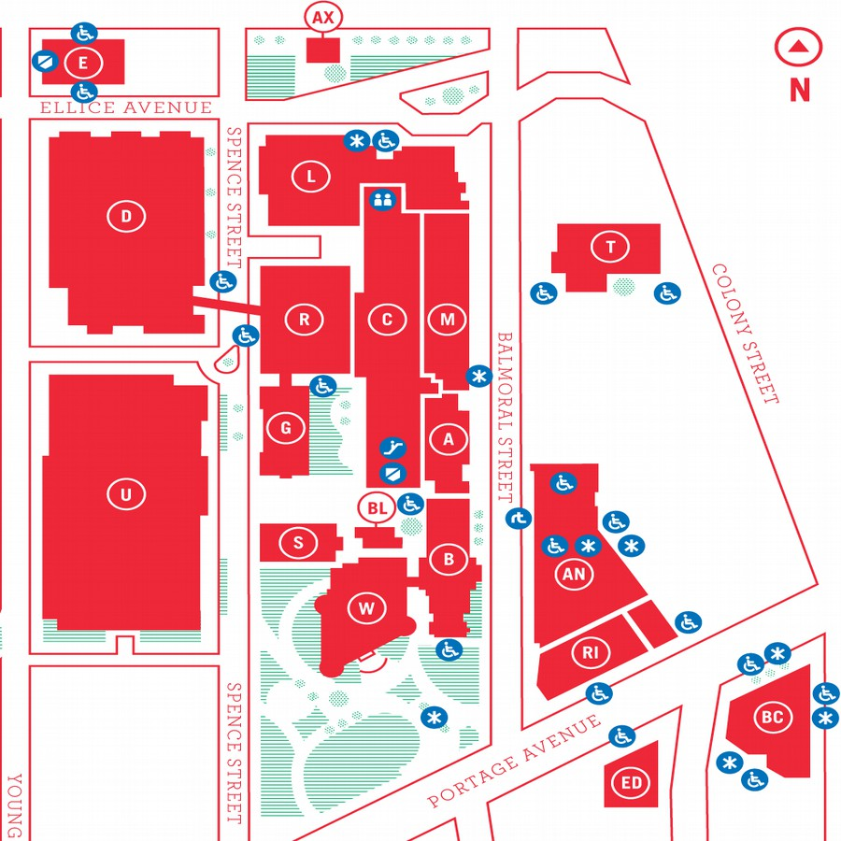
MUUGLines
The Manitoba UNIX User Group Newsletter
Volume 27 No. 7, March 2015 Editor: Trevor Cordes
Next Meeting: March 10, 2015

RTFM and presentation:
In the RTFM segment this month, Brad Vokey will explore the fmt(1), fold(1) and pr(1) commands.
The main presentation will be Les, of Les.net fame, talking about how to build a datacenter.
Door Prize
This month we will be giving away as our door prize the new O’Reilly book Mastering Perl, as well as our usual assortment of magazines. So make sure to come on out for the meeting! Non-members (visitors) are eligible for door prizes too, though the first draw is reserved for members.
MUUG Mugs!
Going, going, gone. We are down to our last few MUUG-logo coffee mugs. If you don’t have yours yet, now is the time to grab one. The price is $15 cash (our cost). Show your support for *NIX and the club and buy yours today!
Where to Find the Meeting

Temporary New Location – Room 1M28!
This month's meeting is on the east side of campus in room 1M28, Manitoba Hall, close to Balmoral Street. Look for a sign on the door We usually hold meetings in room 1L08, but occasionally get relocated to nearby rooms. Parking is available on the surrounding streets. Please see http://www.uwinnipeg.ca/maps for further information about parking and access to the campus.
Funny RTFM of the Month
man mysql
… --safe-updates, --i-am-a-dummy, -U
Allow only those UPDATE and DELETE statements that specify which rows to modify by using key values.
Yes, this author has, once (only, really!), issued a delete from table; before adding the where clause. This knowledge nugget would have saved my bacon.
Mastering Perl 2nd Ed. by brian d foy (O’Reilly) - A Book Review
By Trevor Cordes
Mastering Perl (The Vicuna Book) promises to let you “take the next step toward Perl mastery”, and after reading it, I would say it delivers. As a Perl programmer since 1992, and a self-rated 8 of 10 on the Perl-Expert scale, I wasn’t sure how much I’d glean from this book; but when I learned something new (and useful) on only page 2, I knew this book was a winner. By the end of chapter 1, I was both giddy from all the neat tricks, and giggly from the author’s jocose style. I think every programmer (Perl or otherwise) should read up to page 17, and be prepared to be blown away.
Not only are there obscure new(er) Perl features (of which there are many) on display: you also witness interesting advanced paradigms exposing faster, clearer, terser, methods to achieve common programming idioms. For instance, you can practically discard foreach over arrays or hashes in favour of map, and turn entire loops into one-liners. And you can array-splice a hash and assign to it! My mind is still boggling.
Many useful nuggets are not even the focus of the section: they are just scattered around the copious, short, code examples like little Perl droppings, and left unexplained. With such rewarding flotsam, the meat that is the actual thrust will simply blow you away. Case in point: the listing of R. Schwartz’s JSON parser as a single regex in a grammar-like syntax.

http://www.perlmonks.org/?node_id=995856
The main topics covered that I found most useful were advanced regular expressions (which taught this regex pro a whole new bag of tricks), debuggers, profilers (exceedingly cool), symbol table tricks, dynamic subroutines (no, js didn’t invent them), exceptions, logging, pod and tie trickery.
The author’s levity adds a further dimension to the book, making a potentially dry book quite a lot of fun. Such chuckles as: “I tell Perl not to warn me about what I’m going to do next. That’s a little clue that I shouldn’t do this lightly, but it’s not enough to stop me” and upon showing some naughtiness: “Save this knowledge for a Perl quiz show, and maybe tear it out of this book before you pass it on to a coworker.”
Surprisingly and thankfully, nothing was really over my head, and any mid- to advanced-level Perlmonger should find themselves similarly situated. That said, I would recommend that most readers first read O’Reilly’s Intermediate Perl. The only sentence in the whole book that stuck out as high-fog index, also elicits a chuckle: “I use a symbolic reference to create the subroutine names dynamically, and assign an anonymous subroutine to the typeglob for that name.” That it is the only example speaks volumes as to the deftness of communication of the book as a whole, and, to be fair, that example is from near the end of the book.
I only have two nitpicks, though neither is trivial. Firstly, brian d foy, I mean, come on:

http://www252.pair.com/~comdog/style.html
Secondly, I discovered a relatively huge amount of errors, typos and formatting flaws: around 25 in a 350 page book. In most cases they are obvious and won’t confuse most programmers. However, this is extremely unusual for an O’Reilly book and even more unusual for a second edition. Thankfully O’Reilly provides a public web page to view and submit errata, and I assume my submissions will be fixed for the third edition.

http://tinyurl.com/peoolkm
I also want to note what I consider a formatting error that shows up a couple of dozen times: monospaced bold type sometimes gets split by newlines, right in the middle of words. It happens so many times it may be intentional, but I see little reason for it and it certainly confuses the eye and retards reading speed.
In its entirety, I think I gained more useful, practical knowledge from this book than any other book since my first Perl book so many years ago, Programming Perl (The Camel Book). It is a worthy successor. Whenever I feel blue that Python has stolen all the hearts and minds, I can look back at this book and be reminded that no other language is as clean, terse, flexible, and insane as Perl, and be contented.
Thank you to O’Reilly for donating this book to MUUG.
Nifty RPM Tricks
See all the installed rpms that are provided by the same packager/repo. Very useful for quickly seeing all your packages from RPM Fusion:
rpm -qa packager="*usion*"
It is case-sensitive so I eliminate the “F” in Fusion.
Also useful:
package-cleanup --orphans
To list all rpms without versions found in your current distro version and repo settings. Great for cleaning up after an OS version upgrade.
rpm -qa –last | grep -v \
gpg-pubkey|tail -50
To show you, from bottom up, the oldest rpms on your system. Stale ones often will have dates that stick out like a sore thumb.
Lastly, try:
yum list extras
yum list obsoletes
A Rant Regarding Lennart Poettering’s Rant
Linux Pro Magazine, often a MUUG door prize offering, recently printed a short bit about Lennart, much-maligned systemd and PulseAudio hacker, by editor Joe Casad.

http://tinyurl.com/pvp5yt2
It seems it’s not just MUUG roundtablers miffed at Lennart. I don’t condone nasty ad hominem attacks, and most will agree that Linus often goes over the line, but to me Lennart’s comment smacks of the pot calling the kettle black:
“Poettering denounces the caustic and disrespectful tone used by some open source developers.”
“[T]he Open Source community is full of ****oles, and I probably more than most others am one of their most favourite targets.”
I recall the personal interaction I had with Lennart on bugzilla regarding systemd piping output to less by default. He seemed entirely disrespectful of my opinion, an opinion shared by the dozen other people who also posted on that bugzilla. He cared not one whit about *NIXisms, history, philosophy, etc. But yes, he was not caustic when he told us all to take a hike.
I find it humorous (in a sad way) to this day that his solution to our objection that something in /bin (systemd) can’t depend on a program in /usr/bin (less) was to get Red Hat (through Fedora) to eliminate the distinction, making them all one directory, with /usr/bin becoming a mere symlink to /bin!
Henry Spencer’s quote has never been truer:
“Those who do not understand Unix are condemned to reinvent it, poorly.”
While I personally find systemd livable, being a Fedora 21 user, and even like some of the benefits, I think Lennart (et al.) has done a poor job communicating to the world the whys and wherefores. You want dhcpd in systemd, fine, but first make a case for it and allow everyone else to add their knowledge to the discussion. Lennart needs his own monthly column in Linux Pro Mag, like Maddog and Zack. Also, while technical merits may be present in Lennart’s work, the overall philosophy seems flawed.
Systemd Screwup of the Month
Continuing with systemd, this author recently accidentally discovered that it has taken over fstab handling in initramfs. Yes, we now have a new, non-standard, strange set of stars that must align to ensure our Fedora 21 systems boot properly if disk changes are made.
Previously, if you had a swap drive (or partition) in fstab that no longer existed when you next booted, your system would come up just fine, albeit sans swap. I just found out (the hard way) that systemd refuses to boot if certain (all?) disks listed in fstab by UUID (and perhaps more) are missing or dead. Even Fedora’s rescue mode fails to boot. All you get after a multi-minute timeout is rdshell, a very limited environment, with no indication of what files to tweak because /etc/fstab no longer exists in the initramfs!
There probably is an rdshell solution, but I haven’t found it yet. The only thing that got the system bootable again was booting SysRescCd and doing the mount-bind + chroot + dracut trick. It appears that systemd is making requires-targets for local disks. And it really means “requires”. The temporary solution is to remember to rerun dracut before you reboot when any disk changes occur (including mdadm changes).
My question is: what if a non-critical disk (like swap) dies while the power is off?
Gnome-terminal Has AutoReWrap
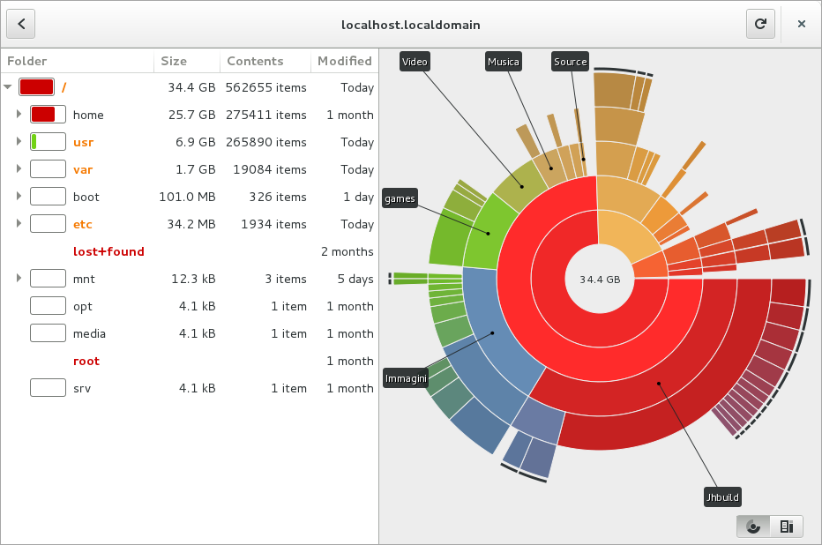
The latest gnome-terminal has the ability to recalculate the line wrapping on existing buffer lines when you resize your terminal using the mouse. This behaviour is much like what screen does, and makes gnome-terminal one of the few (or only) terminals with this feature.
Fedora News
Fedora 21 was released December 9th. As per the new Fedora policy, Fedora 21 is nameless, appearing simply as boring “Twenty One” in system files.
Elsewhere in Fedora-land, Wikipedia reports:
“Linus Torvalds, founder of the Linux kernel, uses Fedora on all of his computers.”
But Linus doesn’t like the terminal defaults in Fedora 21:
"The new gnome-terminal seems to default into a new 'Emo mode' (aka 'Dark Theme'). I don't know who thought it was a good idea to make a terminal application have its own depressed theme different from all other applications, but I'm guessing they spend their days cutting themselves and listening to death metal, and thinking they are 'cool'.”
Save the Planet
Instantly put your monitors to sleep rather than having them stay powered on for <timeout> minutes after you leave your desk for the day:
xset dpms force off
Baobab: Graphical Disk Usage
Baobab provides a nifty, and somewhat unique, view of your file system’s disk usage. It shows each directory level in a polar coordinate-like graph where the size of each arc represents the proportion of usage of one directory compared to the sum of all in that directory. This lets you rapidly pinpoint the disk-hogs. Available in most repositories today.

Book & User Group Discounts

No Starch Press has established a discount for user group members. It's valid for 30% off everything they publish, and it doesn't expire. Use “MUUG” as the discount code when ordering from their website.
http://www.nostarch.com/

