
MUUGLines
The Manitoba UNIX User Group Newsletter
Volume 37 No. 10, June 2025 Editor: Bradford C. Vokey
Next Meeting: June 3rd, 2025 7:30pm
As usual MUUG is meeting on the first Tuesday of the month.

In Person and Online
Until Sep!
Come join us for the last MUUG meeting until September. However, we do also have a summer BBQ planned on July 15th - see the article on page 5.


Mini Presentation:
Wyatt Zacharias has volunteered to give us a quick demo of RawTherapee.
Take your photography to the next level with RawTherapee. Modern DSLR (and now mirrorless) camera sensors are capable of capturing dynamic range far beyond what a standard 8-bit JPG can display. By capturing the raw sensor data from the camera we can access up to 14 bits of dynamic range and adjust our photos non-destructively and without any loss of quality. RawTherapee provides a full suite of photo editing tools including color correction, white balance, noise and distortion correction, and many more.

RTFM: /bin Diving 5.0,
The Brazilian Strikes Back!
Due to overwhelming meeting participation (and a little board member peer pressure), we have somehow convinced our Brazilian board member Alberto Abrao to take a spin at trying to figure out what a random /bin command does live.

The latest meeting details are always at:

https://muug.ca/meetings/
Where to Find the In Person Meeting

Fortress Software Inc.
350 Keewatin St – Unit #2
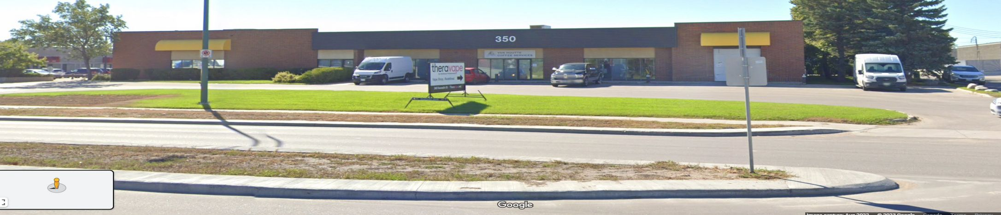
For one last time, we are again meeting at Brad Vokey’s work office at Unit #2 – 350 Keewatin St. The doors will be open at 7:00 pm with the meeting starting at 7:30 pm.
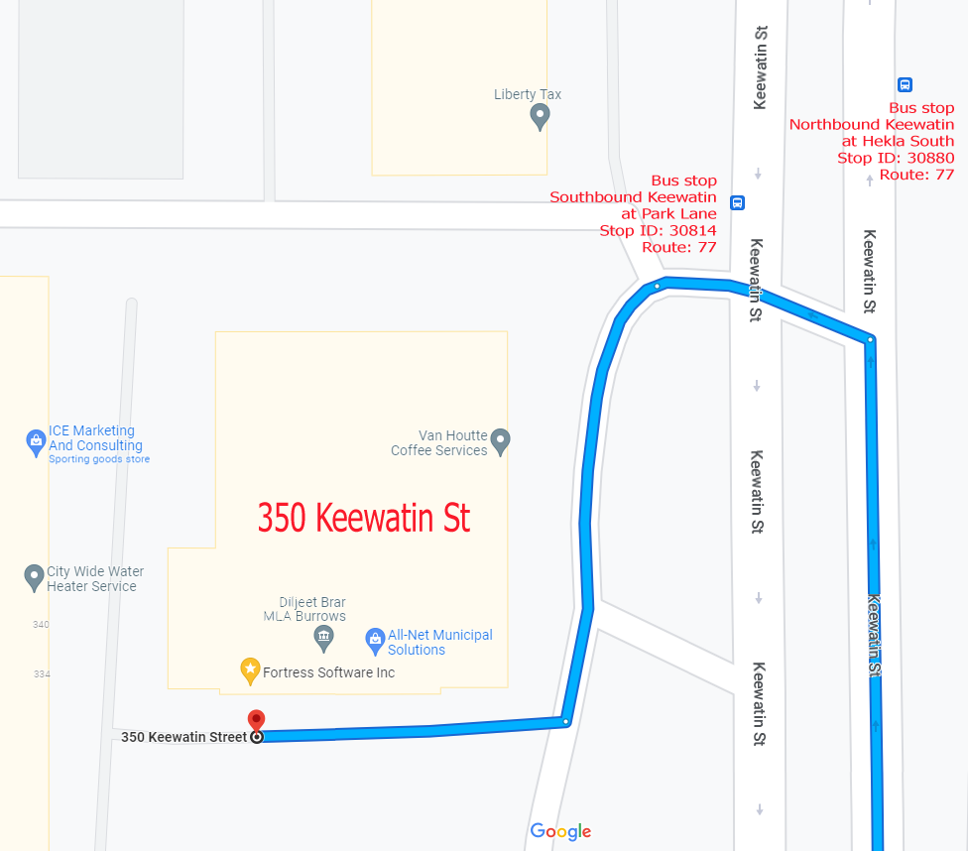
If driving, enter the parking lot using the most north-eastern entrance (far right in the top picture) and drive around to the south west corner of the building (the blue route in the map detail on the right).
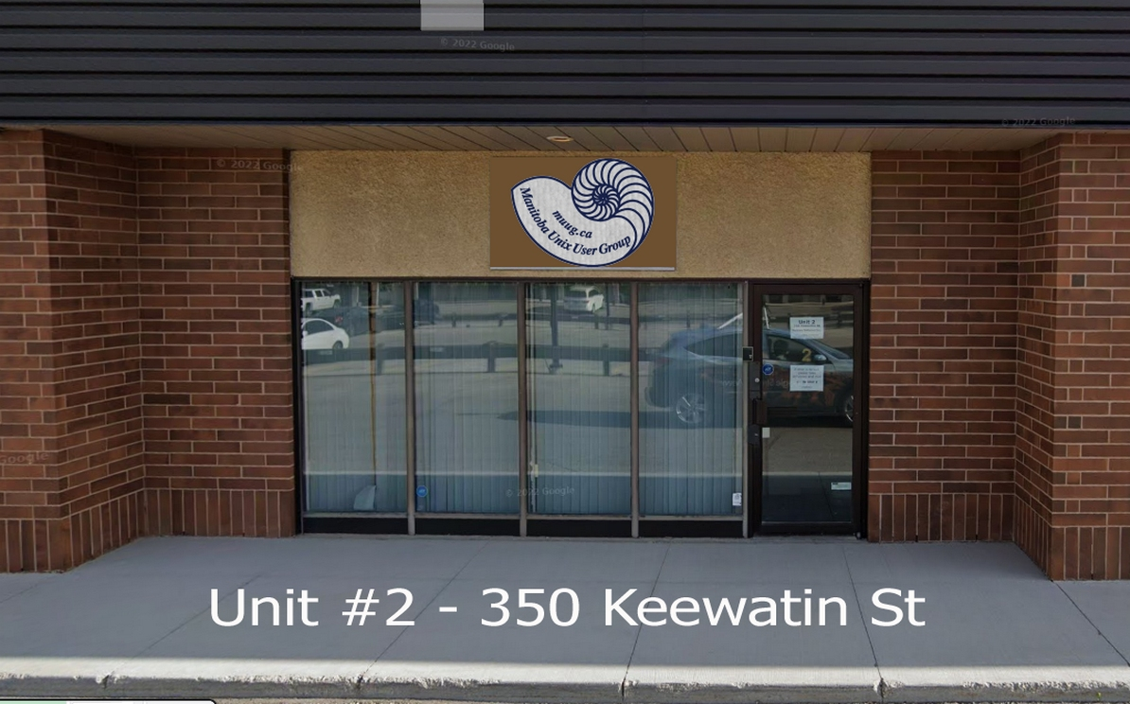
You can park in any of the free, ample, and safe parking spots that say “reserved” in front of units #1 through #4 before entering into unit #2.
Bus stops #30814 and #30880 (route 77) are only 150 meters away. The last bus leaves for Polo Park at 10:15 pm and for Garden City at 10:31 pm.
Logan Ave. bus routes #19, #26, and #27 are a 600 meter (8 minute) walk to the south.
To attend the meeting via the internet:
Go to muug.ca/meet anytime after 7:00 pm on June 3rd. There is no need to create an account in Big Blue Button, nor login. Just enter a name as your screen name and click on the join button.
MUUG Door Prizes

Every month MUUG gives away a couple of tech themed e-books, and some months we even have physical paper books and magazines to give away!
And starting in September, we will have a current copy of Linux Magazine to give away every month!
Everyone is encouraged to enter the door prize draw, both in-person and virtual attendees. You don’t have to be a member to enter, but members have exclusive access to the first draw. Members also get the privilege of not having to be present (physically or virtually) for the draw in order to claim their prize.
Rust turns 10: How a broken elevator changed software forever
Rust 1.0 shipped in May 2015. Here’s how it came about and why it marked a turning point in the world of software development.

Eric S. Raymond, one of open-source’s founders, famously said,
“Every good work of software starts by scratching a developer’s personal itch.”
That was certainly the case with Graydon Hoare, a Mozilla software developer, when he started work on the Rust programming language.
In 2006, Hoare was annoyed with his apartment building’s elevator that kept breaking down. As he later said, “It’s ridiculous that we computer people couldn’t even make an elevator that works without crashing!” He suspected it kept breaking down because of memory errors in its control software, which was likely written in C or C++ which are too easy to write semi-functional code with memory errors.
So Hoare, sick of dragging himself up 21 flights of stairs every day, began designing a new computer language. He wanted to create a small, fast programming language without the potential for memory bugs. He called it Rust, after a family of tough fungi he described as “over-engineered for survival.”
His goal was to create a safe and concurrent language. Unlike C and C++, Rust enforces memory safety through its unique ownership system. It prevents common errors like null pointer dereferencing and buffer overflows by ensuring that each piece of data has a single owner and is automatically freed when it goes out of scope. This approach eliminates entire categories of memory bugs at compile time. Rust’s concurrency model further enhances safety by catching data races before the code runs, making it easier for developers to write programs that are both safe and efficiently concurrent.
This wasn’t easy. While it began as a home project, Mozilla saw the potential and started officially sponsoring Rust in 2009. The language was publicly announced in 2010, and after years of iteration, Rust 1.0 shipped on May 15, 2015.
That was 10 years ago.
The first stable release of the Rust programming language quietly marked a turning point in the world of software development. Today, Rust is not just a technical achievement but a testament to the power of community-driven innovation, transforming from a Mozilla-backed experiment into a mainstream tool embraced by tech giants and open-source communities alike.

https://www.zdnet.com/article/rust-turns-10-how-a-broken-elevator-changed-software-forever/
No More Xorg!
Fedora 43 Will Be Wayland-only
After 2.5 years, a massive THANK YOU to Fortress Software Inc. (fsi.ca) for providing us with an in-person meeting space for 22 meetings since March of 2023.
Thanks to Linux Mag for providing MUUG a half price magazine subscription for our door prizes.
Linux Magazine is your guide to the world of Linux and open source. Each monthly issue includes advanced technical information you won’t find anywhere else including tutorials, in-depth articles on trending topics, troubleshooting and optimization tips, and more! Subscribe to their free newsletters and get news and articles in your inbox.

https://www.linux-magazine.com/
MUUG would like to thank Michael W. Lucas for donating one of his ebooks every month as a door prize. You can view and purchase his tech books here:

https://www.tiltedwindmillpress.com/product-category/tech/
Further to last month’s article about Fedora 42...
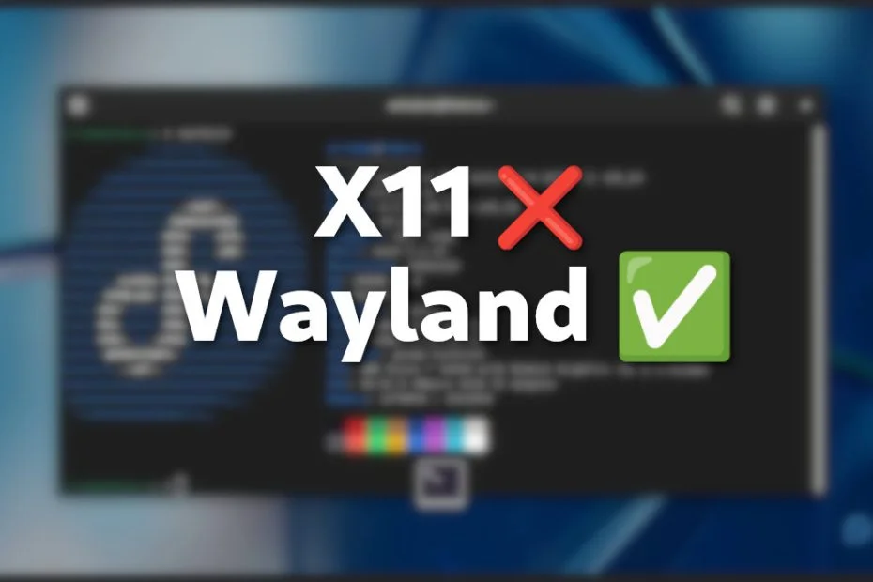
As part of the upcoming Fedora 43 release, Workstation will no longer feature an X11 session, defaulting to a Wayland-only policy, with all X11 packages being removed from the new release that is set to come equipped with GNOME 49.
All GNOME X11 components will be removed from Fedora Workstation. As a result, the GNOME X11 session will no longer be available, and existing users will be automatically switched to the Wayland session.
Those who prefer using X11 will have to either switch to using a different login manager and desktop environment combo that supports X11 or move to Fedora Spins such as Xfce, Cinnamon, or MATE, which will continue to offer X11 sessions.
It’s only a matter of time before GNOME drops X11 completely. GNOME 50 is already targeting this change, having removed X11 session targets, with the full removal of X11 session code panned next.
[This author is now glad he picked KDE for his desktop of choice all those many moons ago...]

https://news.itsfoss.com/fedora-43-wayland-only/
KDE’s X11 Support to Continue Until Plasma 7
KDE has separated KWin X11 and KWin Wayland. Wayland takes priority, but X11 remains maintained until Plasma 7.

https://linuxiac.com/kde-x11-support-to-continue-until-plasma-7/
Linus Torvalds Reflects on 20 Years of Git
Linus Torvalds knew what developers wanted for their SCM: Performance, safeguards against data corruption and distributed workflow.

Linus Torvalds wrote the Git distributed version control system and on April 7th, 2005 he made the first commit. So in early April, GitHub celebrated and had GitHub staff software engineer Taylor Blau conduct an interview with Torvalds.
The first question provided some crucial context. Did Torvalds still expect to be using and talking about Git 20 years later?
Help us promote this month’s meeting, by putting this poster up on your workplace bulletin board or other suitable public message board:

https://muug.ca/meetings/MUUGmeeting.pdf
Except where otherwise noted, all textual content is licensed under a Creative Commons Attribution-ShareAlike 4.0 International License.

https://creativecommons.org/licenses/by-sa/4.0/
A big thanks to Les.net for providing MUUG with free hosting and all that bandwidth! Les.net (1996) Inc. is a local provider of VoIP, Internet and Data Centre services. Contact sales@les.net by email, or +1 (204) 944-0009 by phone.
The creator of Linux answered that he’d expected to still be using Git — but “maybe not talking about it.” He’s surprised that it didn’t just persist, but came to dominate the source-control management (SCM) space for developers around the world — because “I saw it as a solution to my problems.”
Torvalds uses the interview to reflect on all the little lessons learned — about network effects, workflows, and the importance of simplicity in problem-solving.
And by the end of the interview, he was weighing in on whether or not Git had actually changed the act of programming itself.
In 2007 Torvalds (who is credited for writing git in just 10 days) said:
“The implementation is really simple, 80,000 lines and mostly in C.”

Original Article: https://thenewstack.io/linus-torvalds-reflects-on-20-years-of-git/

YouTube Video: https://youtu.be/sCr_gb8rdEI
Mozilla is rolling out Thundermail,
a Gmail, Office 365 rival

Thunderbird, Firefox maker Mozilla’s open-source email client, is aiming to reinvent itself as a more comprehensive communications platform.
Toward that end, the development team is in the process of rolling out a set of adjacent services, some of which may eventually bring in revenue.
Ryan Sipes wrote in a blog post from April 4th:
Today we’re pleased to announce what many in our open source contributor community already know. The Thunderbird team is working on an email service called “Thundermail” as well as file sharing, calendar scheduling and other helpful cloud-based services that as a bundle we have been calling “Thunderbird Pro.”
First, a point of clarification: Thunderbird, the email app, is and always will be free. We will never place features that can be delivered through the Thunderbird app behind a paywall. If something can be done directly on your device, it should be. However, there are things that can’t be done on your computer or phone that many people have come to expect from their email suites. This is what we are setting out to solve with our cloud-based services.
Read the full article to get a sense of the new planned services including:
- Thunderbird Appointment
- Thunderbird Send
- Thunderbird Assist
- Thundermail

https://blog.thunderbird.net/2025/04/thundermail-and-thunderbird-pro-services/

MUUG 4th Annual BBQ


Come one, come all, to the MUUG summer BBQ
Spouses, significant others, and children are also welcome to attend.
Date: July 15th, 2025
Time: 6:30 pm
Location: BBQ Site #5, Assiniboine Park
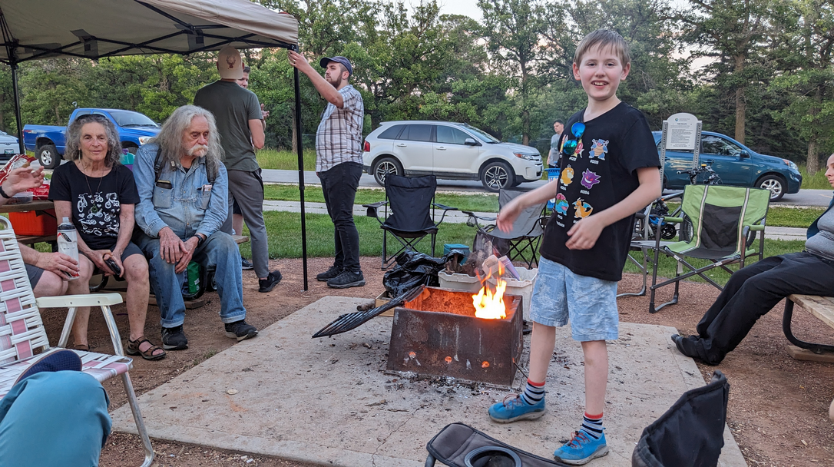
For the 4rd year in a row MUUG is hosting another BBQ event. This year we are at the exact same location as last 2 years (Assiniboine Park at site #5).
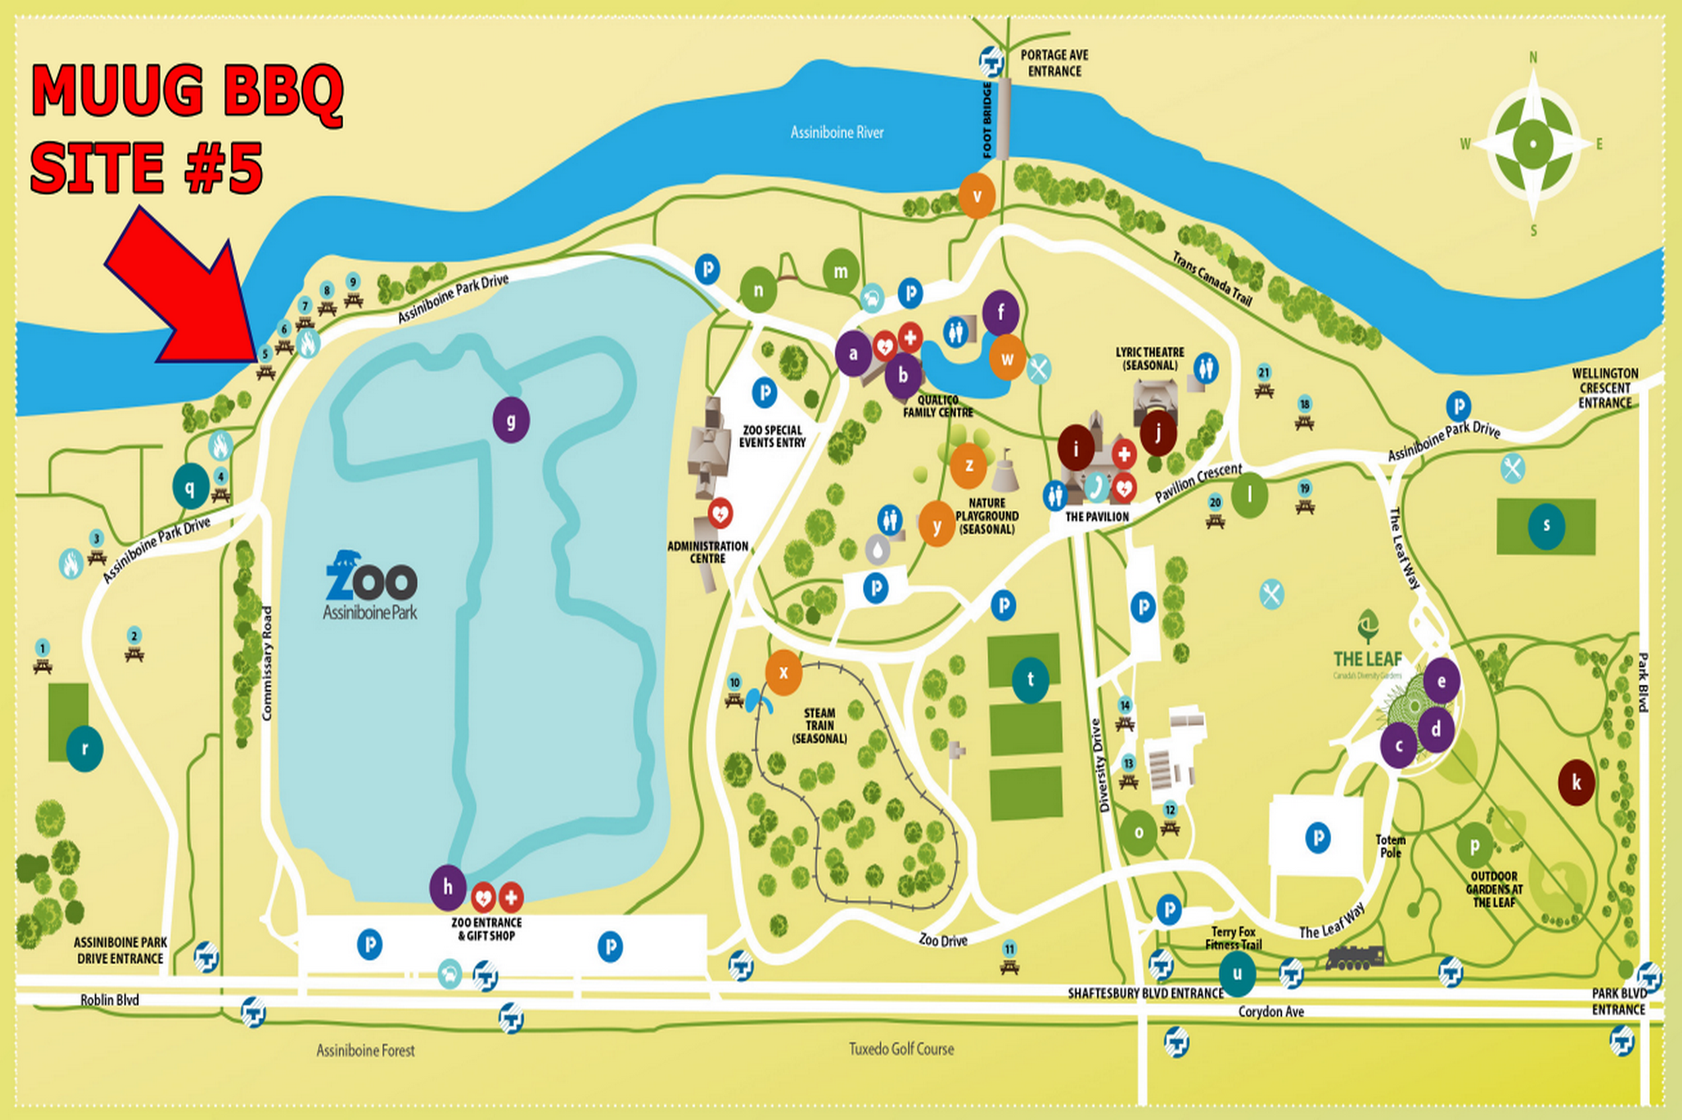
Burgers, hot dogs, and pop will be provided by MUUG. Feel free to bring your own food to share with others and your own beverages if you like.

Please RSVP via email to: bbq@muug.ca before July 8th so we know how much food we need to buy and bring.
$1,000 worth of Free Credit Card Processing!

If you ever have a need to collect credit card payments be sure to sign up with Square
(the credit card processor that MUUG uses) and both you and MUUG will receive $1,000 in free processing for the next 6 months (180 days).
You must use the following referral link to receive the credit:
https://squareup.com/i/MANITOBAU1

